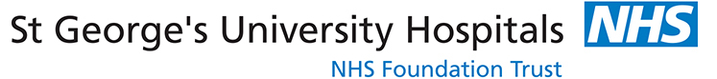

BREAST MRI STUDY DAY (Teams)

Aim: To cover the typical imaging appearances of benign and
malignant breast disease on MR, to cover the latest
Indications for Breast MRI, High Risk Breast Screening with
MRI and cover Advances in Breast MRI

When: 15th MARCH 2022

Course Organiser: Dr Sarah McWilliams, St George’s National
Breast Education Centre

Aimed At: Consultants, Advanced Practitioners and

Registrars with a special interest in Breast Imaging

Where: Online via Microsoft Teams

Fee: £225 Consultant Radiologists £195 All Clinicians

Programme to include:

CESM, Running a VHR Service, Indications for Breast MRI, MRI BIRADs, High Risk Screening, Abbreviated MRI Imaging, Role of PET in Staging Breast Cancer, Benign Lesions.

Book now as places are limited. To Register Contact:

Irene Davis on 0208 725 1534 or irene.davis@stgeorges.nhs.uk
Breast Education Centre, The Rose Centre, St George’s Hospital, Perimeter Rd, Tooting SW17 0QT www.stgbec.org.uk

