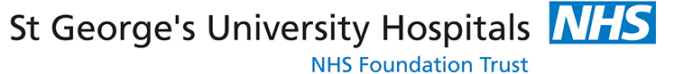

NATIONAL BREAST EDUCATION CENTRE

MASTER CLASS FOR STAFF PREPARING FOR
DUTY OF CANDOUR INTERVIEWS

DATE: MONDAY 20TH JUNE 2022

AT st george’s HOSPITAL - the rose centre seminar room

(For: Directors of Screening, Consultant Surgeons, Consultant Radiologists and Clinical Nurse Specialists)

This Master Class is of value to clinical staff in Breast Imaging and Breast Screening. The format consists of small group work and practical clinical demonstrations with an experienced faculty.
There is the opportunity for delegates, if they wish, to participate in simulated clinical scenarios.
The day covers the principles of effective communication, how best to share difficult information in the context of Duty of Candour, and deal with the range of responses (including anger). The workshop aims to improve skill and confidence in difficult situations. A pre-requisite for attendance is to complete the following NHSBSP Toolkit that will support the study day: https://portal.e-lfh.org.uk/, then select breast screening duty of candour & disclosure of audit eLearning course (3 elements) in the search box.

This course has been approved by the RCR for 5 Category 1 CPD credits

Cost: £225 Consultants £195 All Clinicians

FACULTY:

Clinical Nurse Specialist: Claire Bailey
Radiographic Adviser to NHSBSP: Claire Borrelli
Reader in Medical Education: Dr. Katherine Joekes
Breast Surgeon: Ms Karyn Shenton – Kingston & St George’s Hospitals
Consultant Radiologists: Dr. Rosalind Given-Wilson, Dr. Mamatha Reddy & Dr. Catherine Morris.

Book now as places are limited. Please contact Irene Davis on 0208 725 1534 or email Irene.davis@stgeorges.nhs.uk The National Breast Education Centre at The Rose Centre, Perimeter Road, London SW17 0QT.

